# Data Flow Diagram:

**PROJECT DESIGN PHASE-II**

**DATA FLOW DIAGRAM & USER STORIES**

|  |  |
| --- | --- |
| Date | 2/ 11/ 2022 |
| Team ID | PNT2022TMID05693 |
| Project Name | Project - Smart Waste Management System For Metropolitan Cities |
| Maximum Marks | 4 Marks |

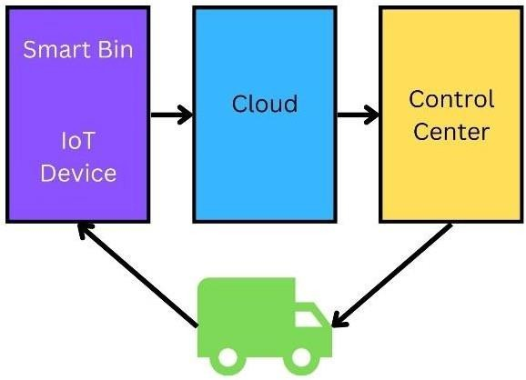

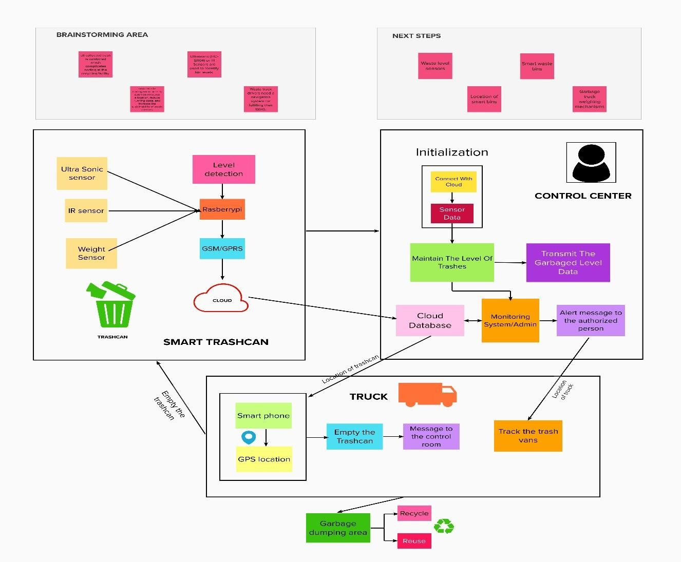**Simplified Diagram The IoT device is fitted in the trashcans.**

* The sensors in the device senses the garbage level.
* The GSM/GPRS will send the information about the garbage level to the cloud.
* The admin in the control center notifies the authorized person to collect the garbage.
* The truck driver will be notified the route to the filled dumpsters.
* The trashes are loaded to the truck.
* The more number of bins needed in high populated area.
* The overflowing of trashcans can be avoided.
* No missed pickups of trashcans.
* New smart dustbins can be install by just connecting the IoT device to the cloud.

# User Stories:

|  |  |  |  |  |  |  |
| --- | --- | --- | --- | --- | --- | --- |
| **User Type** | **Functional**  **Requirement (Epic)** | **User**  **Story Number** | **User Story / Task** | **Acceptance criteria** | **Priority** | **Release** |
| Admin | Login | USN-1 | As an admin, I can monitor every dustbin  and its garbage levels. | I can monitor the  system. | High | Sprint-4 |
|  |  | USN-2 | As an admin, I will inform the authorized  person to empty the trashcan. | I can inform authorized  person. | Medium | Sprint-2 |
|  |  | USN-3 | As an admin, I can notice the trash level of every dustbin. | I can notice the trash level. | Low | Sprint-2 |
| Admin 2 | Login | USN-4 | As a Co-Admin, I can send alert message  to the truck drivers. | I can alert truck driver. | High | Sprint-1 |
| Trash Van Driver | Login | USN-5 | As a trash van driver, I will follow the route to the dustbin. | I can reach the filled trashcans. | High | Sprint-2 |
| Garbage Collector |  | USN-6 | As a waste collector, I will collect all the  trash from the dumpsters and load it to the truck. | I can empty the trashcans. | Medium | Sprint-2 |

|  |  |  |  |  |  |  |
| --- | --- | --- | --- | --- | --- | --- |
| **User Type** | **Functional**  **Requirement (Epic)** | **User**  **Story Number** | **User Story / Task** | **Acceptance criteria** | **Priority** | **Release** |
| Municipal officer | Login | USN-7 | As a municipality officer, I can supervise the process and ensure the cleanliness of city. | I can manage all these process going good. | High | Sprint-1 |
| Trashcan Monitor | Register | USN-8 | As a trashcan monitor, I can initialize new trashcans. | I can register new smart trashcans. | Medium | Sprint-3 |
|  |  | USN-9 | As a trashcan monitor, I can check the  quality of IoT device’s quality. | I can check the IoT  device. | Medium | Sprint-3 |